BOOK CLUB 2017 READING LIST
6:30PM-7:30pm at the Lodi Memorial Library: director@lodi.bccls.org for more info

Tuesday, January 10, 2017
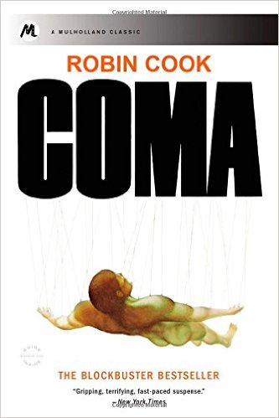
Coma by Robin Cook-384 pages
They called it "minor surgery," but Nancy Greenly, Sean Berman and a dozen others--all admitted to Boston Memorial Hospital for routine procedures--were victims of the same inexplicable, hideous tragedy on the operating table. They never woke up.
Susan Wheeler is a third-year medical student working as a trainee at Boston Memorial Hospital. Two patients during her residency mysteriously go into comas immediately after their operations due to complications from anesthesia. Susan begins to investigate the causes behind both of these alarming comas and discovers the oxygen line in Operating Room 8 has been tampered with to induce carbon monoxide poisoning.
Then Susan discovers the evil nature of the Jefferson Institute, an intensive care facility where patients are suspended from the ceiling and kept alive until they can be harvested for healthy organs. Is she a participant in--or a victim of--a large-scale black market dealing in human organs?

Tuesday, February 14, 2017
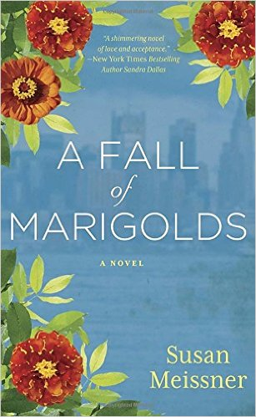

A Fall of Marigolds By Susan Meissner- 400 pages
A beautiful scarf, passed down through the generations, connects two women who learn that the weight of the world is made bearable by the love we give away....
September 1911. On Ellis Island in New York Harbor, nurse Clara Wood cannot face returning to Manhattan, where the man she loved fell to his death in the Triangle Shirtwaist Fire. Then, while caring for a fevered immigrant whose own loss mirrors hers, she becomes intrigued by a name embroidered onto the scarf he carries…and finds herself caught in a dilemma that compels her to confront the truth about the assumptions she’s made. Will what she learns devastate her or free her? September 2011. On Manhattan’s Upper West Side, widow Taryn Michaels has convinced herself that she is living fully, working in a charming specialty fabric store and raising her daughter alone. Then a long-lost photograph appears in a national magazine, and she is forced to relive the terrible day her husband died in the collapse of the World Trade Towers…the same day a stranger reached out and saved her. Will a chance reconnection and a century-old scarf open Taryn’s eyes to the larger forces at work in her life?
Tuesday, March 14, 2017
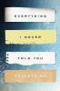
Everything I Never Told You by Celeste Ng-297 pages
Lydia is dead. But they don't know this yet . . . So begins the story of this exquisite debut novel, about a Chinese American family living in 1970s small-town Ohio. Lydia is the favorite child of Marilyn and James Lee; their middle daughter, a girl who inherited her mother's bright blue eyes and her father's jet-black hair. Her parents are determined that Lydia will fulfill the dreams they were unable to pursue--in Marilyn's case that her daughter become a doctor rather than a homemaker, in James's case that Lydia be popular at school, a girl with a busy social life and the center of every party. When Lydia's body is found in the local lake, the delicate balancing act that has been keeping the Lee family together tumbles into chaos, forcing them to confront the long-kept secrets that have been slowly pulling them apart. James, consumed by guilt, sets out on a reckless path that may destroy his marriage. Marilyn, devastated and vengeful, is determined to find a responsible party, no matter what the cost. Lydia's older brother, Nathan, is certain that the neighborhood bad boy Jack is somehow involved. But it's the youngest of the family--Hannah--who observes far more than anyone realizes and who may be the only one who knows the truth about what happened.A profoundly moving story of family, history, and the meaning of home, Everything I Never Told You is both a gripping page-turner and a sensitive family portrait, exploring the divisions between cultures and the rifts within a family, and uncovering the ways in which mothers and daughters, fathers and sons, and husbands and wives struggle, all their lives, to understand one another.
BOOK CLUB 2017 READING LIST
6:30PM-7:30pm at the Lodi Memorial Library: director@lodi.bccls.org for more info

Tuesday, April 11, 2017
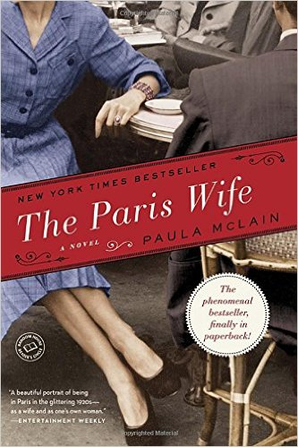

The Paris Wife by Paula McLain-331 pages
A deeply evocative story of ambition and betrayal, The Paris Wife captures the love affair between two unforgettable people: Ernest Hemingway and his wife Hadley. Chicago, 1920: Hadley Richardson is a quiet twenty-eight-year-old who has all but given up on love and happiness—until she meets Ernest Hemingway. Following a whirlwind courtship and wedding, the pair set sail for Paris, where they become the golden couple in a lively and volatile group—the fabled “Lost Generation”—that includes Gertrude Stein, Ezra Pound, and F. Scott Fitzgerald.
Though deeply in love, the Hemingways are ill prepared for the hard-drinking, fast-living, and free-loving life of Jazz Age Paris. As Ernest struggles to find the voice that will earn him a place in history and pours himself into the novel that will become The Sun Also Rises, Hadley strives to hold on to her sense of self as her roles as wife, friend, and muse become more challenging. Eventually they find themselves facing the ultimate crisis of their marriage—a deception that will lead to the unraveling of everything they’ve fought so hard for.
A heartbreaking portrayal of love and torn loyalty, The Paris Wife is all the more poignant because we know that, in the end, Hemingway wrote that he would rather have died than fallen in love with anyone but Hadley.

Tuesday, May 9, 2017
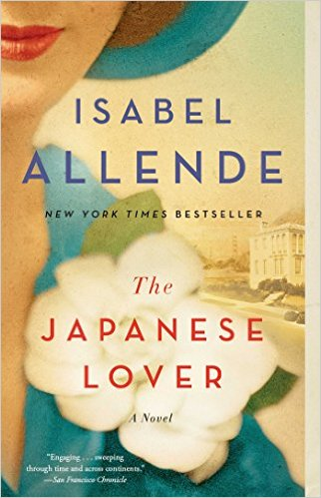
The Japanese Lover by Isabel Allende- 336 pages
From New York Times bestselling author Isabel Allende, “a magical and sweeping” (Publishers Weekly, starred review) love story and multigenerational epic that stretches from San Francisco in the present-day to Poland and the United States during World War II.
In 1939, as Poland falls under the shadow of the Nazis, young Alma Belasco’s parents send her away to live in safety with an aunt and uncle in their opulent mansion in San Francisco. There, as the rest of the world goes to war, she encounters Ichimei Fukuda, the quiet and gentle son of the family’s Japanese gardener. Unnoticed by those around them, a tender love affair begins to blossom. Following the Japanese attack on Pearl Harbor, the two are cruelly pulled apart as Ichimei and his family—like thousands of other Japanese Americans—are declared enemies and forcibly relocated to internment camps run by the United States government. Throughout their lifetimes, Alma and Ichimei reunite again and again, but theirs is a love that they are forever forced to hide from the world.
Decades later, Alma is nearing the end of her long and eventful life. Irina Bazili, a care worker struggling to come to terms with her own troubled past, meets the elderly woman and her grandson, Seth, at San Francisco’s charmingly eccentric Lark House nursing home. As Irina and Seth forge a friendship, they become intrigued by a series of mysterious gifts and letters sent to Alma, eventually learning about Ichimei and this extraordinary secret passion that has endured for nearly seventy years.
Sweeping through time and spanning generations and continents, The Japanese Lover is written with the same keen understanding of her characters that Isabel Allende has been known for since her landmark first novel The House of the Spirits. The Japanese Lover is a moving tribute to the constancy of the human heart in a world of unceasing change.

BOOK CLUB 2017 READING LIST
6:30PM-7:30pm at the Lodi Memorial Library: director@lodi.bccls.org for more info

Tuesday, June 13, 2017

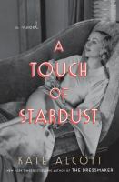
A Touch of Stardust by Kate Alcott-304 pages
From the New York Times bestselling author of The Dressmaker comes a blockbuster novel that takes you behind the scenes of the filming of Gone with the Wind , while turning the spotlight on the passionate romance between its dashing leading man, Clark Gable, and the blithe, free-spirited actress Carole Lombard. When Julie Crawford leaves Fort Wayne, Indiana, for Hollywood, she never imagines she'll cross paths with Carole Lombard, the dazzling actress from Julie's provincial Midwestern hometown. The young woman has dreams of becoming a screenwriter, but the only job Julie's able to find is one in the studio publicity office of the notoriously demanding producer David O. Selznick, who is busy burning through directors, writers, and money as he films Gone with the Wind . Although tensions run high on the set, Julie finds she can step onto the back lot, take in the smell of smoky gunpowder and the soft rustle of hoop skirts, and feel the magical world of Gone with the Wind come to life. Julie's access to real-life magic comes when Carole Lombard hires her as an assistant and invites her into the glamorous world Carole shares with Clark Gable, who is about to move into movie history as the dashing Rhett Butler.

Tuesday, July 11, 2017

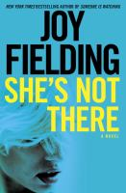
She’s Not There by Joy Fielding-369 pages
"A lifetime ago, every year Carole Shipley looked forward to her wedding anniversary. But then a celebratory trip to Mexico for the occasion with her husband and friends ended in the unsolved kidnapping of her infant daughter, Samantha. Now, fifteen years after that horrific time, divorced and isolated, Carole is forced to relive the kidnapping by reporters who call every year on the anniversary of Samantha's disappearance. However, this year when the phone rings, Carole hears the sweet voice of a girl claiming to be her long-lost daughter. Plunged back into the world of heartbreak, suspicion and questions that led the case to run cold so many years ago, Carole doesn't know what or who to believe. But when she starts to figure it out, she finds the answers dangerously close to home.

Tuesday, August 8, 2017
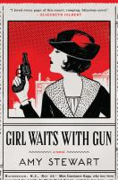
Girl Waits with Gun by Amy Stewart-448 pages
Constance Kopp doesn t quite fit the mold. She towers over most men, has no interest in marriage or domestic affairs, and has been isolated from the world since a family secret sent her and her sisters from city to country fifteen years ago. When a powerful, ruthless factory owner runs down their buggy, a dispute over damages turns into a war of bricks, bullets, and threats as he unleashes his gang on their farm. The sheriff enlists her help, and it turns out Constance has knack for outwitting (and disarming) the criminal element that might just take her back out into the world and onto a new path in life. Quick-witted and full of madcap escapades, Girl Waits with Gun is a story about one woman rallying the courage to stand up for and grow into herself with a little help from sisters and sheriffs along the way.

BOOK CLUB 2017 READING LIST
6:30PM-7:30pm at the Lodi Memorial Library: director@lodi.bccls.org for more info

Tuesday, September 12, 2017
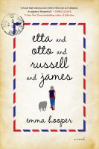
Etta, Otto, Russell, and James by Emma Hooper-320 pages
A gorgeous literary debut about unlikely heroes, lifelong promises, and last great adventures.
Otto,
The letter began, in blue ink,
I’ve gone. I’ve never seen the water, so I’ve gone there. Don’t worry, I’ve left you the truck. I can walk. I will try to remember to come back.
Yours (always),Etta.
Otto finds the note left by his wife in the kitchen of their farmhouse in windswept Saskatchewan. Eighty-three-year-old Etta will be walking 3,200 kilometers to see the ocean, but somehow, Otto understands. He took his own journey once before, to fight in a faraway land. With Etta gone, Otto struggles with his demons of war, while their friend Russell initially pursues the woman he has loved from afar. And James—well, James you have to meet on the page. Moving from the hot and dry present of a quiet Canadian farm to a dusty, burnt past of hunger, war, and passion, from trying to remember to trying to forget, Etta and Otto and Russell and James is an astounding literary debut about friendship and love, hope and honor, and the romance of last—great—adventures.

Tuesday, October 10, 2017
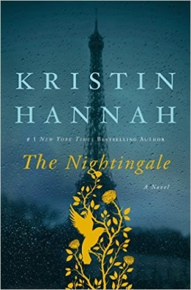
The Nightingale by Kristen Hannah-440 pages
Viann and Isabelle have always been close despite their differences. Younger, bolder sister Isabelle lives in Paris while Viann lives a quiet and content life in the French countryside with her husband Antoine and their daughter. When World War II strikes and Antoine is sent off to fight, Viann and Isabelle's father sends Isabelle to help her older sister cope. As the war progresses, it's not only the sisters' relationship that is tested, but also their strength and their individual senses of right and wrong. With life as they know it changing in unbelievably horrific ways, Viann and Isabelle will find themselves facing frightening situations and responding in ways they never thought possible as bravery and resistance take different forms in each of their actions.

Tuesday, November 14, 2017
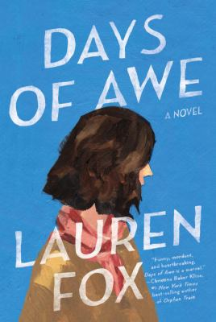
Days of Awe by Lauren Fox-272 pages
An achingly funny novel about a woman who, after her best friend's death, must face several crises. -- Only a year ago Isabel Moore was married, the object of adoration of her ten-year-old daughter, and thought she knew everything about her wild, extravagant, beloved best friend, Josie. But in that one short year: her husband moved out and rented his own apartment; her daughter grew into a moody insomniac; and Josie, impulsive, funny, secretive Josie, was killed behind the wheel in a single-car accident. As Isabel tries to make sense of this shattering loss and unravel the months leading up to Josie's death, she comes to understand the shifts, large and small, that can upend a friendship and an entire life. Heartbreaking and wryly funny, this is a masterly exploration of marriage, motherhood, and the often surprising shape of new love.

BOOK CLUB 2017 READING LIST
6:30PM-7:30pm at the Lodi Memorial Library: director@lodi.bccls.org for more info

Tuesday, December 12, 2017
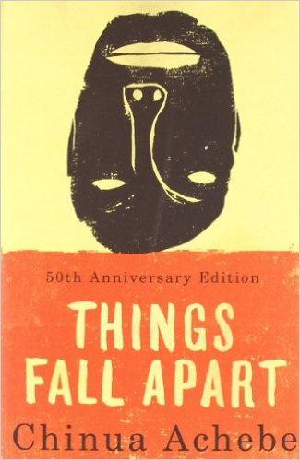
Things Fall Apart by Chinua Achebe, 209 pages
This cherished contemporary classic of Nigerian literature—and the first volume of Achebe's celebrated African Trilogy—tells two intertwining stories, both centering on Okonkwo, a “strong man” of an Ibo village. The first, a powerful fable of the immemorial conflict between the individual and society, traces Okonkwo’s fall from grace with the tribal world. The second, as modern as the first is ancient, concerns the clash of cultures and the destruction of Okonkwo's world with the arrival of aggressive European missionaries. These perfectly harmonized twin dramas are informed by an awareness capable of encompassing at once the life of nature, human history, and the mysterious compulsions of the soul.

Tuesday, January 9, 2018
The Improbability of Love by Hannah Rothschild, 512 pages
Annie McDee, thirty-one, lives in a shabby London flat, works as a chef, and is struggling to get by. Reeling from a sudden breakup, she’s taken on an unsuitable new lover and finds herself rummaging through a secondhand shop to buy him a birthday gift. A dusty, anonymous old painting catches her eye. After spending her meager savings on the artwork, Annie begins to suspect that it may be more valuable than she’d thought. Soon she finds herself pursued by parties who would do anything to possess her picture: an exiled Russian oligarch, an avaricious sheikha, an unscrupulous art dealer. In her search for the painting’s identity, Annie will unwittingly discover some of the darkest secrets of European history—and the possibility of falling in love again.

